The Irish Piemontese Cattle Society Ltd.
Breeding Programme
Adopted by the Irish Piemontese Council on 20th February 2023

Table of contents:

- Name of the breed
- Aim of the Irish Piemontese Breeding Programme
- Geographical Territory
- Breed Characteristics of the Piemontese Breed
- System for the identification of animals
- Criteria for entry into the breeding book
- Control checks
- System of recording pedigrees
- System for the registration of animals
- System for the registration of embryo animals
- Selection and Breeding Objectives of the Irish Piemontese Breeding Programme
- Performance testing and genetic evaluations
- Zootechnical Certificate
- Imports/Exports
- Sale of stock
- Outsourced management
- Authorised derogation

The Irish Piemontese Breeding Programme may be found on the Irish Piemontese Breed Society website at: www.irishpiemontesesociety.com

- Name of the Breed:
Piemontese

- Aim of the Irish Piemontese Breeding Programme:
The aim of the Irish Piemontese Breeding programme is to maintain the purity of the Piemontese breed in Ireland and to improve the quality of the Irish herd. The aim is to produce an early maturing high quality Piemontese animal which conforms as closely as possible to the animal described in Breed Characteristics.
Taking the above into consideration, the council will, as necessary, purchase stocks of straws which will be stored in an approved AI company store.

- Geographical Territory:
The geographical territory in which the society will operate shall be The Republic of Ireland.

- Breed Characteristics of the Piemontese Breed:
The following are the characteristics that define the Piemontese breed.
It is a beef breed of medium size that converts forage very well into beef and has a high dressing out percentage.
The breed is noted for its natural longevity.
Head: This should be fine in character, triangular in shape with a broad forehead, a fine nose and a broad muzzle. It is a horned breed.
Bone: They should have very fine bones; this contributes to a high kill-out rate.
Skin: They have a fine and elastic skin; this signifies a low quantity of external fat and lean and tender, but tasty meat.
Colour: The bulls have a grey or fawn coat, with black hairs on the head (especially around the eye sockets), on the neck, the shoulders, the distal regions of the limbs and sometimes on the lateral faces of the body and the hind limbs.
The cows have a white or pale fawn coat with shades of grey.
At birth the coat of the calves is of a deep or pale fawn colour.
The tongue, the palate and the external mucosa are black.
Body: They should have a broad and muscular chest, wide withers, muscular loins, a long trunk and a good muscular development of the rump and the inner and outer thighs.
Locomotion: They should have well set on legs giving good ease of locomotion.
The cows are of medium size (550 – 600 kg).
Calves: At birth the calves weigh on average from 40 – 45 kg. The Double Muscle does not become apparent until several weeks post calving and so does not contribute to any calving difficulty.
Double muscle: A distinct characteristic of the Piemontese cattle breed is hypertrophy, better known as the ‘double muscle factor’ caused by a natural mutation which causes a considerable increase in muscular mass and consequently in dressing out percentage, due to an increase of the muscular fibres. Furthermore, it causes a decrease of the quantity of inter-muscular fat and of connective tissue, giving major tenderness to the meat. The double muscle factor is due to the gene variant C313Y.
Slaughter: The male fattening calves are ready for slaughtering at a weight of 550 – 650 kg when they are about 15 – 18 months old. The female calves are ready for slaughtering at a weight of approximately 350 – 450 kg when they are about 14 – 16 months old. The carcase contains only a small percentage of fat and has a low percentage of bones; the beef is of excellent quality. The quantity of commercial cuts is higher than that of bigger sized breeds.
Docility: It is a docile breed and it is important to maintain this aspect of the breed character.

- System for the identification of breeding animals:
All animals are uniquely identified in the Breeding book by their national bovine identification number (NID) supplied by the Department of Agriculture. Imported animals will carry the ID or breeding book number of their country of origin.
Each member must make application to register an approved Prefix/Herd name. The prefix name shall not have been allocated to another member of the society either in the past or at present. The name shall be applicable to all animals bred and notified by that member, either alone or jointly with any partners or other persons in any one herd. The appropriate fee must be paid to secure the use of a herd name.
In addition, each animal must be individually named and shall be known by the Prefix/Herd name and its birth name, the total number of spaces available on the registration system is 30 characters including the gap between the two names. The first letter of the name must be that of the current Society year letter, for example each animal born in 2021 shall have a name commencing with the letter “S”.

- Criteria for entry into the breeding book:
The breeding book shall have a Main Section only.
Main Section:
To qualify for entry into the Main Section of the breeding book an animal shall:
    - Be descended from parents and grandparents entered in the main section of a breeding book of the same breed.
    - Be identified at birth according with European Union animal health law and the rules set out in the Society’s breeding programme.
    - Have a pedigree established in accordance with the rules set out in the Society’s breeding programme.
    - Where an animal is traded in or entered into the European Union and is intended to be entered in the breeding book the animal shall be accompanied by a zootechnical certificate.
    - Where an animal is produced from a germinal product which is traded or which is entered into the European Union and where the animal is intended to be entered in the breeding book the germinal product shall be accompanied by a zootechnical certificate.

The Main Section of the breeding book shall be divided into two classes, as follows:
Class 1: To qualify for entry in Class 1 of the Main section of the breeding book an animal shall meet the requirements as outlined above and be free from genetic defects i.e. over shot and under shot mouth, and excessively straight or sickled legs. Breeders should notify the Society of any genetic defects in their stock in order to increase the knowledge about breeding lines and promote responsible breeding decisions. From 01/01/2020, the sire and dam of animals entering Class 1 must have a DNA/Genomic test number.
Class 2: To qualify for entry in Class 2 of the Main section of the breeding book an animal must meet the minimum criteria for entry in the Main Section as outlined above but does not meet the criteria for class 1 (i.e. if he/she has been identified as being a carrier of a genetic defect), or have undesirable breed characteristics, (i.e. poor docility) or for calves born after 01/01/2020 whose sire and dam do not have a DNA/Genomic test number. The progeny of an animal from a Class 2 parent (sire or dam) shall be entered in class 2 of the breeding book

- Control checks:
- All bulls used for natural service must be DNA/Genomic tested and sire verified, by an approved laboratory, before their progeny can be accepted for entry into the breeding book.
- All bulls used for semen harvesting, including AI stud bulls, must have their DNA/Genomic profile recorded. These bulls must be sire and dam verified and have undergone a genetic evaluation in order for their progeny to enter the breeding book.
- All sires born after the 01/01/2020 must be DNA/Genomic tested and sire and dam verified.
- From the 01-01-2020 all dams must have a DNA/Genomic profile recorded.
- In the case of an AI bull, the straws must have an ICBF issued AI code.
- All calves born by embryo transfer must be sire and dam verified. The donor dam must have undergone performance testing or genetic evaluation.
- Where any change is made (other than a name change) to the details of an animal this will automatically trigger a DNA/Genomic test requirement.
- Where the sire and dam of a calf were not in the same ownership at the time of service, (except in the case where an AI handheld unit records the insemination) a properly authorised service or insemination certificate verifying this service or insemination must, unless otherwise decided by the Council, be submitted when the calf is tendered for entry into the herd book.
- Where calves are born as a result of a DIY insemination, a copy of the inseminator’s DIY licence and expiry date with a list of straws purchased may be requested by the Society.
- Imported stock must be accompanied by a zootechnical certificate issued by the breeding book of the state of export.
- Where an in-calf female is imported from outside the state point 14 of the zootechnical certificate for the dam must be completed. In the case of official mating records not being available, parentage verification through DNA/Genomic testing will have to be carried out and the registration of the calf will be delayed pending results. The onus is on the breeder to seek out this information.
- Germinal products, such as straws and embryos must be accompanied by a zootechnical certificate.
- Every 25th calf notified to the society shall be weighed, by an agreed technician, along with any purebred animal in the herd under 12 months of age.
- Entry into the breeding book will not be completed until the appropriate fee is paid.
- The IPCS reserves the right to carry out, at their own discretion, random DNA/Genomic testing, at the breeder’s expense on all animals.
- Any animal failing parentage verification will not be entered in the societies’ breeding book.

- System for recording pedigrees:
Pedigrees of purebred breeding animals are recorded on the electronic database called “Taurus” which is provided by the ICBF (see Outsourcing of Technical Activities). The information recorded for each animal shall be: National Identification Number (NID), herd number, animal’s name, date of birth, sex, twinning, defects, name, NID number and breeding book section of sire and dam, grand sires and grand dams, and great grand sires and great grand dams, the registration class of the animal and the name and address of the breeder and owner.

- System for the entry of animals into the breeding book:
The birth of every calf whose entry is desired to be entered in the Society’s breeding book shall be notified through the DAFM Animal Events system/database, giving the date of birth, sex, ear tag number, dam’s ear tag number, sire ID and name of the calf. This information is then populated via the ICBF database to the Society’s “Taurus” database.
Both the dam and sire of any calf which a member desires to enter in the Society’s breeding book should (from 01/01/2020) have a DNA/Genomic profile. If they do not have both the calf will be entered in class 2.
After 01/01/2020 animals not entered through the DAFM Animal Events system/database may be notified directly to the Administrator and shall be accepted subject to the animal seeking entry having its parentage (sire and dam) verified by DNA/Genomic testing and to.
The cost of any DNA/Genomic testing will be paid by the member and the Society reserves the right to request the owner to do additional DNA/Genomic testing at their expense and of any animal thought necessary by the Council.

Animals imported into Irish Republic should be notified directly to the Administrator and accompanied by the appropriate entry fee as decided by the Council. Zootechnical certificates must be submitted with imported animals.
The fact of an animal being twin or otherwise one of a multiple birth shall be notified to the Society on-line, stating the sex of the other twin, or other calves. This information shall be noted in the Society’s breeding book against the entry of such an animal.
The Society reserves the right to enter the notification of birth of a calf, where the date provided is deemed to be deficient or inaccurate, in Class 2 of the Herdbook
Where calves are born as a result of an insemination/service/fertilisation procedure from a bull not owned by the breeder, a certificate stating such shall be forwarded to the Society. If the insemination is automatically recorded on a handheld unit which submits the information directly to the ICBF website this shall be deemed sufficient notice.
In the case of a sire located outside the state, and entered in another breeding book the member shall supply a copy of the zootechnical certificate that accompanied the semen. The onus is on the breeder to seek out this information.
All donor bulls born after the 01/01/2020 shall be fully parentage tested, sire and dam verified, before progeny can be accepted for entry into the breeding book. Donor bulls born before 01/01/2020 should also be fully parentage tested, sire and dam verified, however entry of their progeny into the breeding book is at the discretion of the Council. However, these donor bulls must have a genetic evaluation by an approved laboratory.
An administration fee will be charged for all named animals even where it is not desired to complete the registration.
Entry into the Breeding Book will not be completed until the appropriate fee is paid.

Where an error occurs, the registration is placed in a holding category in the Society’s database. Once the problem is rectified the registration will be completed. In the event of the issue not being resolved by breeding book staff, the breeder is notified of the position. The breeder must then notify the Society with the necessary amendment by email or in writing.

Members are obliged to keep a register containing a true and accurate record of all their cattle eligible for entry into the breeding book by the Society. The details of dates and particulars of inseminations, dates of birth, weights of calves etc shall be recorded.

- System for registration of embryo animals:
In the case of embryo transplant, embryos must be notified to the Society on the appropriate triplicate embryo registration form, which must be properly and accurately filled out and signed by both the owner of the donor female and the representative of the approved collection team. One copy of this form must be sent to the Society within fourteen days of the completion of the embryo collection procedure, be it direct recovery, or other appropriate technique and be accompanied by the appropriate fees currently in force. A second copy should be retained by the approved embryo transplant team and a third copy should be retained by the breeder.
When an embryo duly notified as above in any way changes its status by means of thawing, implantation, change of ownership etc., this change of status must be notified to the Society on an approved Embryo Amendment Form, appropriately signed.
In the case of calves born as a result of embryo transfer, both donor sire and dam must be parentage tested (sire and dam) by means of DNA/Genomic testing, by an approved laboratory prior to the animal being eligible for entry.
Donor dams must have undergone performance testing or genetic evaluation.
The cost of any DNA/Genomic testing will be paid by the member and the Society reserves the right to request the owner to do additional DNA/Genomic testing at their expense and of any animal thought necessary by the Council.

- Selection and Breeding Objectives:
The selection and breeding objectives of the IPCS are formulated to maintain and improve the Piemontese breed of cattle in the Republic of Ireland, using careful selection and genetic improvement.
The Breed Improvement Programme operates to attain the breeding objective of the IPCS.
The breeding objective is to produce an early maturing high quality Piemontese animal that is suitable for the European market. This is achieved through the genetic improvement of traits such as slaughtering age, live weight gain, feed conversion efficiency, dressing-out percentage, carcass characteristics, meat quality, calving ease and fertility. In addition, milk production is considered in the selection. Furthermore, breeding objectives are concerned with eliminating any genetic flaws.
The traits of the ideal Piemontese animal are: medium size, good fertility, short gestation, easy calving, good milk production, good docility, good live weight gain, efficient feed conversion, early slaughtering age, with excellent carcase characteristics and meat quality, good conformation and locomotion, good longevity, fine bones and skin, double muscling and high dressing out percentage.
The tools used in making this selection to meet the breed improvement objectives are: visual assessment, stockmanship, performance recording, genomic testing and high reliability breeding predictions (using the ICBF data collection, evaluation, genomic testing information and Eurostars. The Eurostar index allows the society to monitor the success of the breed improvement programme in respect of the aforementioned traits. Careful selection, by members of council, of suitable AI straws is made in order to assist in the implementation of the requirements of the breed improvement programme.
Further detailed information on the evaluations carried out by ICBF for IPCS is available at https://www.icbf.com/wp/wp-content/uploads/2019/05/Beef-Evaluation-Document.pdf.

- Performance testing and genetic evaluations:

The IPCS undertake ‘Performance Testing’ and ‘Genetic Evaluation’ as part of their breeding programme. These services are made available to breeders and are provided by ICBF. There are 3 main objectives for the Piemontese breed:

- Replacement: To breed future cows for the Piemontese suckler herd.
- Terminal: To breed terminal sires for progeny that is destined for slaughter.
- Dairy Beef: To breed terminal sires for progeny from the dairy herd that is destined for slaughter.

Following are the weightings of the traits in these indexes:

 | Index Trait Weightings
 | Dairy Beef | Replacement | Terminal
Calving | 64% | 16% | 26%
Carcass | 27% | 39% | 56%
Fertility |  | 23%
Milk |  | 18%
Docility |  | 4% | 2%
Feed Intake |  |  | 16%
Other | 9%

Performance Testing

The following data is collected as part of performance testing

- Calving Survey
Each Breed Society member records ancestry and calving data on their calves through the ‘Animal Events’ recording system. The Calving Survey options are: 1=Normal Calving,
2=Some assistance, 3=Considerable difficulty, 4=Vet assistance. ‘Abortion or ‘Calf died at birth may also be recorded.
This data is used in the calculation of calving difficulty of an animal.

- Liveweight & Morphological traits
Whole Herd Performance Recording (WHPR) is available to Breed Society members to participate and is a process through which breeders can get relevant liveweight and morphological trait data recorded on their pedigree animals. Following is a description of the data recorded on the various types of animals in a herd:
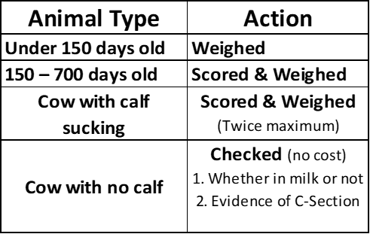
Following is a list of the morphological traits that are recorded on pedigree animals at a WHPR visit.
Genetic  Evaluation use | Traits recorded |  | Pedigree  Males &  Females | Pedigree  Calved  Females | Pedigree  Calved  Females | Pedigree  Males &  Females | Dry Cows &  Uncalved Females | Panel Section (Functional, Skeletal, Breed Quality, Muscle)
 |  |  | 1-149 days | 1st Scoring | 2nd+  Scoring | 150-700 days
Replacement & Terminal €uro-Stars | 1 | Weight (kg) | Yes | Yes | Yes | Yes
 | 2 | Width at Withers |  |  |  | Yes |  | Muscle
 | 3 | Width Behind Withers |  |  |  | Yes |  | Muscle
 | 4 | Loin Development |  |  |  | Yes |  | Muscle
 | 5 | Dev Hind Quarter |  |  |  | Yes |  | Muscle
 | 6 | Thigh Width |  |  |  | Yes |  | Muscle
 | 7 | Height at Withers |  |  |  | Yes |  | Skeletal
 | 8 | Length of Back |  |  |  | Yes |  | Skeletal
 | 9 | Pelvic Length |  | Yes |  | Yes |  | Skeletal
 | 10 | Width at Hips |  |  |  | Yes |  | Skeletal
 | 11 | Docility |  | Yes | Yes | Yes
 | 12 | Milkability (1-5)* |  | Yes | Yes
Func BLUP | 1 | Fore Legs Front View |  | Yes |  | Yes |  | Functionality
 | 2 | Hind Legs Side View |  | Yes |  | Yes |  | Functionality
 | 3 | Hind Legs Rear View |  | Yes |  | Yes |  | Functionality
 | 4 | Locomotion |  | Yes | Yes | Yes |  | Functionality
Cow  Traits | 1 | Teat placement |  | Yes | Yes
 | 2 | Teat size |  | Yes | Yes
 | 3 | Udder suspension |  | Yes | Yes
(  Other Traits  As decided by each breed | 1 | Width of Pelvis |  | Yes |  | Yes |  | Skeletal
 | 2 | Rump angle |  | Yes |  |  |  | Breed Quality
 | 3 | Width at Pins |  | Yes |  | Yes |  | Skeletal
 | 4 | Condition score |  | Yes |  | Yes |  | Muscle
 | 5 | Dev Inner Thigh (1 to 15) |  |  |  | Yes |  | Muscle
 | 6 | Width of Chest |  |  |  | Yes |  | Skeletal
 | 7 | Canon Bone Thickness |  |  |  | Yes |  | Breed Quality
 | 8 | Depth of Chest |  |  |  | Yes |  | Skeletal
 | 9 | Level of Back |  |  |  | Yes |  | Functionality
 | 10 | Width at Hips |  |  |  | Yes |  | Skeletal
 | 11 | Harmony |  |  |  | Yes |  | Breed Quality
 | 12 | Width of Muzzle |  |  |  |  |  | Breed Quality
 | 13 | Colour of Head |  |  |  |  |  | Breed Quality
 | 14 | Type of Head |  |  |  | Yes |  | Breed Quality
 | 15 | Girth |  |  |  | Yes |  | Breed Quality
 | 16 | Rib |  |  |  |  |  | Breed Quality
 | 17 | Plates |  |  |  | Yes |  | Breed Quality
 | 18 | Depth of Rump (1 to 10) |  |  |  | Yes |  | Breed Quality
 | 19 | Tail Set |  |  |  |  |  | Breed Quality
 | 20 | Colour of Tail |  |  |  |  |  | Breed Quality
 | 21 | Depth of Hoof |  |  |  |  |  | Breed Quality
 | 22 | Scrotal Circumference |  |  |  | Yes |  | Breed Quality
 | 23 | Colour of Head |  |  |  |  |  | Breed Quality
 | 24 | Hair Type |  |  |  |  |  | Breed Quality
 | 25 | Shoulder Muscle (1 to 15) |  |  |  |  |  | Breed Quality
 | 26 | Top Muscle (1 to 15) |  |  |  |  |  | Breed Quality
 | 27 | White Patches |  |  |  |  |  | Breed Quality
 | 28 | Skin Thickness |  |  | Yes |  |  | Breed Quality
Edit Info | 1 | Cow in milk (rearing a calf): Y/N |  | Yes | Yes |  | Yes
 | 2 | Mastitis on Day of Scoring (Y/N) |  | Yes | Yes
 | 3 | Mastitis Since Last Calving (Y/N) |  | Yes | Yes
 | 4 | Evidence of C-section Last Calving: Y/N |  | Yes | Yes |  | Yes
 | 6 | Lameness on day of scoring (Y/N) |  | Yes | Yes
 | 7 | Lameness since last calving (Y/N) |  | Yes | Yes
 | 8 | Sick on the Day of Scoring (Y/N) | Yes | Yes | Yes | Yes
 | 9 | *16 Extra Indicators (below) | Yes | Yes | Yes | Yes
*US=Undershot,OS=Overshot,NT=Undescended Testicle,OT=One Testicle,DW=Dwarf,CD=Claw, HD=Hip
Defect,TD=Tongue Defect,CD=Colour Defect,SD=Scurs Defect,PD=Pastern Defect, GD=Genetic Dam,BR=Bucket

The traits above are used in the calculation of an animal’s ‘Linear Type’ breeding values. They are grouped into ‘Muscle’, Skeletal’ and ‘Functional’. The breeding values of an animal in a herd participating in WHPR can be found by clicking on the ‘Linear Type’ page in an animal’s
‘Animal Search’ output on the ICBF website e.g. https://webapp.icbf.com/v2/herdbook/index.php?vAnimalType=2&end=1 or
https://webapp.icbf.com/v2/app/bull-search/view/998726033

Data collected on Liveweight & Morphological traits provides a strong base of accurate phenotypic data and can increase the accuracy and the reliability % of an animal’s ‘€uro-Stars (see below).

Genetic Evaluations

The ICBF beef evaluation system uses ‘€uro-Stars’ as its main method of breeding value output. The Euro-Star Index is a breeding index designed to aid beef farmers in the selection of more profitable breeding animals. Euro-Star Indexes quantify the genetic component of an animal’s performance across all traits of importance. The Euro-Star Index has two overall indexes – the Replacement Index and the Terminal Index. Breeders can use the appropriate index for their animals depending on their farming systems i.e. breeding replacements or for beef.
Replacement Index: There are 17 traits included in the Replacement Index. Each trait has its own Predicted Transmitting Ability (PTA). An animal’s PTA is the amount of a trait that it can pass on to its progeny. The PTA for each trait is then multiplied by the Economic Weight (monetary value for each unit of the trait) to generate a Euro value contribution for the trait. All the values are added up to provide an overall Replacement Index. Table 1 details the traits included in the Replacement Index as well as their respective Economic Weights.
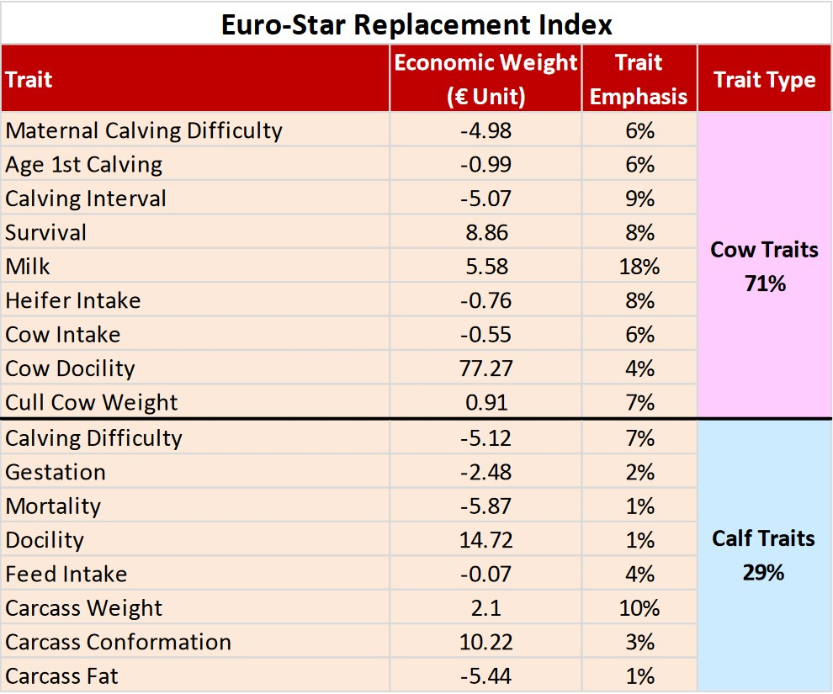
Table 1. Traits included in the Replacement Index and their Economic Weights.

Terminal Index: There are 8 traits included in the Terminal Index. Each trait has a PTA and an Economic Weight which are multiplied to give the Euro value contribution of that trait. All the relevant trait contributions are added up to provide a overall Terminal Index. Table 2 details all of the traits included in the Terminal Index as well as their respective Economic Weights.
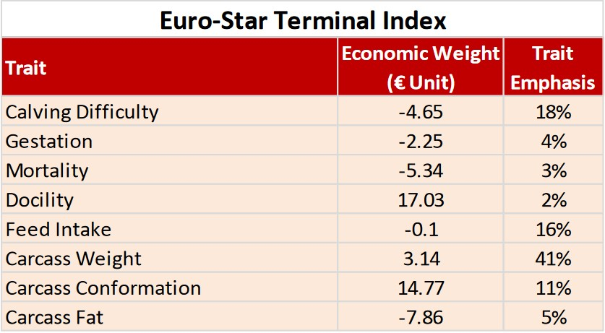
Table 2: Traits included in the Terminal Index and their Economic Weights.

Evaluations for the breed are also performed across-country through Interbeef. Breeders can assess the genetic merit of a bull in the Irish condition via his Interbeef ranking. These breeding values cannot be compared to the national breeding values. Further information can be found at: https://www.icbf.com/wp/?page_id=13498.
Genomics
The Society requires genomic recording of all animals before they acquire purebred registered status i.e. Entry into the main section (Class 1) of the breeding book. Genomics can increase reliability figures (by about 20%) even before animal performance data becomes available, provides accuracy to gauge potential performance of the animal from the genetic traits and confirms parentage of the animal (assuming parents are genotyped) or can predict a sire. More details on the ICBF Genomics service can be found at: https://www.icbf.com/wp/?page_id=7876

Methodology
ICBF extracts the performance, pedigree and genotype data from the database 6 times per year. The ICBF Animal Evaluation unit uses SAS for pre-processing and post-processing of data before and after the genetic evaluation run itself. 'Mix 99' is used for variance component estimation and for the actual running of the genetic evaluations. The ICBF genetic evaluations are computed 6 times a year. Further information on the genetic evaluation schedules can be found at www.icbf.com/wp/?page_id=11285.
The rules and standards applied for genetic evaluation are those established by Interbull. Further details can be found at: https://wiki.interbull.org/public/beef_guidelines?action=print&rev=64

Communication and use of Performance Testing and Genetic Evaluation Results
The star rating system (1 to 5 stars where 5 is best and 1 worst) is incorporated into the Euro-Star Index to assist breeders in assessing the results for their breeding animals and using this information when considering their selection objectives. However breeders must note
  - Stars within and across breed
  - Star ratings are assigned to multiple indexes and traits
  - The PTA for the specific index or trait first.
  - The Trait Emphasis is the average contribution of each trait to the index of the average proven AI bull. Breeders should consider which trait is of importance to their breeding programme and the corresponding percentage assigned to the trait.
  - The Reliability Figure gives an indication as to how confident that an index or trait figure will not change in the future as more data is recorded.

Further information on the Eurostars can be found on
https://issuu.com/herdplus/docs/euro-star_system_explained
https://www.icbf.com/wp/?p=12929

Information to breeders on Genetic Evaluations is available through
  - ICBF animal search https://webapp.icbf.com/v2/app/bull-search/
  - AI bull listings https://www.icbf.com/wp/?page_id=206
  - Herdplus Reports https://www.icbf.com/wp//wp-content/uploads/2018/05/ICBF-Beef-User-Guide.pdf
  - Zootechnical Certificates(ZC)
  - Breed Society Sale Catalogue
  - Participating Mart Boards

- Zootechnical Certificate:
A zootechnical certificate for each animal, that meets the criteria for entry into the breeding book, shall be issued to the animal’s owner by the society within one month of when all criteria are met and payment of entry fees are made. The onus is on the owner of the animal to verify that all information on the certificate is correct, and if not, to contact the society’s office with the corrections within one calendar month of the issue of the certificate.
The breeder is the person who enters the animal in the breeding book. The owner is the person in whose herd the DAFM records show the animal to be recorded.
Results of relevant genomic tests, performance testing and/or genetic evaluations are published on the zootechnical certificate.
A twin animal will have the circumstances of its twinning (twinned to male/twinned to female) published on its zootechnical certificate.
An animal found to have a genetic defect or peculiarity following inspection shall have details of this published on its zootechnical certificate and shall be entered in class 2 of the breeding book.
If an animal changes ownership a new certificate will be issued on payment of the current transfer fee, and the names of both the breeder(s) and new owner(s) shall appear on the zootechnical certificate.
Any animal that has not received a zootechnical certificate may not be sold as a purebred breeding animal.
Where the animal fails parentage verification the zootechnical certificate must be returned to the administrator. If alternative parentage can be verified using appropriate DNA/Genomic testing, a new certificate can be issued on payment of an administrative fee.
An administration fee will be charged for all named animals even where it is not desired to complete the registration.

- Imports/Exports:
Each imported animal must be entered in the Society breeding book as soon as possible by submitting the Zootechnical Certificate issued by a recognised breed society or a listed breeding body for the breed from the country of origin, and the normal entry fee.
Imported germinal products (straws and embryos) must be accompanied by the relevant zootechnical certificates and DNA/Genomic test certificates.
Imports and exports of animals, embryos, semen etc., should comply with the national regulations in place at the time.

- Sale of stock:
The procedure for the change of ownership is that the new owner receives the ZC when taking ownership of a purebred animal. If the new owner is a member of the IPCS and wants a ZC in their name they complete the details on the reverse of the ZC and submit it to the Society office where if everything is in order the ZC will be reissued to the new owner with the name of the new owner displayed on it.

- De-registration of stock:
An animal that fails parentage verification will be de-registered and all its progeny will lose their Purebred status. Any ZC ‘s that have been issued for the animal or it’s progeny must be returned to the office and fees paid to the society will not be refunded. A breeder may request to have an animal de-registered. Any ZC’s that have been issued for the animal must be returned to the office and fees paid to the society will not be refunded.
A de-registered animal, that has parents and grandparents that are fully registered in the Herdbook of the IPCS, or any Herdbook of another Society of the same breed, can be re-registered in the Herdbook of the IPCS at the required fee and without the consent of the breeder.

- Outsourced management:
The society uses the Taurus system provided by ICBF to be notified of animal entries into the breeding book and record details of animals. Taurus is an Electronic system for recording & maintaining the pedigree of breeding animals entered into the breeding book
The Society uses the Taurus system to generate Zootechnical certificates.
The Society may use the Taurus system to generate catalogues for various purposes.
The Society uses the performance testing and genotyping service operated by the ICBF to authenticate and evaluate the animals in the breeding book.
Contact details for ICBF are as follows:
Irish Cattle Breeding Federation Society Limited (ICBF)
Link Road, Ballincollig. P31 D452 Co. Cork.
Email: query@icbf.com
Website: www.icbf.com

The Irish Piemontese Society or its agents accept no liability as to the accuracy of evaluations computed. No representation or warranty expressed or implied is made or is given by the IPCS Ltd. or its agents as to the accuracy, reliability, completeness of any report provided. The IPCS Ltd. shall not be liable for any losses (whether direct or indirect), damages, costs or expenses whatsoever, incurred or arising from any use of a report or data compiled.

Administrator: Lesley Sandes, Ballyhasty, Cloughjordan, Co. Tipperary. E53 HX85 piemcattleadmin@gmail.com

- Authorised derogations:
The Irish Piemontese Cattle Society has, on 11-2-19, been granted a derogation to allow the following approved semen collection centres, semen storage centres, embryo collection and/or production teams approved for intra Union trade, as appropriate to issue a zootechnical certificate as provided under Article 31 (1) of CR 2016/1012:

Dovea Genetics, Dovea, Thurles, Co. Tipperary.
Bova A.I., Ballyart, Brittas, Co. Limerick.
NCBC, Kilcroney, Enfield, Co. Meath.
NCBC, Unit K4, M7, Business Pk., Naas, Co. Kildare.
NCBC, and Munster Farm Services Group Ltd., Ballyvorisheen, Mallow, Co. Cork.
Cooney Island Genetics, Gortaganny, Castlerea, Co. Roscommon.
Eurogene AI Services (Ireland) Ltd., Carrigeen Industrial Est., Chair, Co. Tipperary.
Sligo AI, Stokane, Enniscrone, Co. Sligo.
Dunmasc Genetics Ltd., Rockview, Dunmaise, Portlaoise, Co. Laois.
XYZ Genetics T/A World Wide Sires Ltd., 605 Red Centre, Harbour Pt. Business Pk.,
Little Island, Cork.
Elite Pedigree Genetics, Unit 5, Kileef Business Pk., Silverstream, Co. Monaghan.
Celtic Sires, Coolrain, Portlaoise, Co. Laois.
Bull Bank, Ballaghaline, Doolin, Co. Clare.
Kevin Genetics, Falmore, Gleneely, Inishowen, Co. Donegal.
Champion Embryos, Deerpark, Ballyfin, Portlaoise, Co. Laois.
Genexcel Irl. Ltd., Animal Breeding Services, Tullymurrihy, Ballinascarty, Co. Cork.
Laurance Dunn MVB, MRCVS, Ballyorney Enterprises Ltd., Enniskerry, Co. Wicklow.
Bovi Genetics, Cowmaster Ltd., Drembannow, Loughduff, Co. Cavan.
J. F. Brody, Trans Embryo, Prospect Hse., Athenry, Co. Galway.
Bova AI Embryo & Scanning Technologies, Castlemore Ldg., Tullow, Co. Carlow.
Animal Reproductive Technologies Ltd., Boston Hill, Rathangan, Co. Kildare.
Beirne Farm Services, Caldra, Elphin, Co. Roscommon.
Thomas Griffin, Ballyvara, Doolin, Co. Clare.
Glengoyne Genetics, Kiltoal, Convoy, Lifford, Co. Donegal.
Daire Markham, Clydaugh Upper, Ballinlough, Co. Roscommon.

Appendix 1

Schedule of fees for members of IPCS
New membership: €150.00
Annual Membership (due on 1st Jan. annually): €100.00
Associate and Commercial Membership: €50.00
Appeals Deposit: €150.00

Calf Registration: Female €40.00
Male €20.00
Late registration fee: €80.00
Named calf with reg. uncompleted €10.00
Duplicate Certificate, €20.00
Embryo calf registration €60.00 + DNA/Genomic test

Eurogene delivery fee for straws: A delivery fee of €40.00 +23% vat (€49.20) will apply to all deliveries of straws to any tank.

Schedule of fees for non-members of IPCS:
Calf Registration: Female €60.00
Male €40.00
Late registration fee: €100.00
Membership for 1 year: €50.00
Re-registration of a qualifying animal previously de-registered or sold without a ZC by its owner: €200.00

All cheques should be made payable to Irish Piemontese Society and sent to L. Sandes, Ballyhasty, Cloughjordan, Co. Tipperary.
Payment can be made on line using the following details, please notify the office 087/6381199 when making an online payment.
IBAN: IE49AIBK93522023251029 BIK: AIBKIE2D

